

icc global & regional pathway events -

MEDICAL handbook TEMPLATE

**(Appendix – C)**

|  |  |
| --- | --- |
| INDEX | Page |
| Purpose and Scope | 3 |
| Medical Management Structure | 3 |
| Key Medical Staff | 3 |
| Match Day Medical Protocols and Chain of Command | 4 |
| Host Country Information | 9 |
| Concussion | 10 |
| Medical Services in Host Cities | 12 |
| General Medical Services | 12 |
| Match Day Medical Services & Facilities | 14 |
| Medical Services at Training | 15 |
| Medical Services at Team Hotel | 16 |

*Note*

*This Medical Handbook template will assist the Host Member/ Tournament Medical Manager (TMM) in providing teams with the necessary medical information required for the ICC Event.*

*Host/TMM will be required to input information into the highlighted sections of this handbook and follow instructions where provided.*

*Please send a copy of the Event Medical Handbook to the ICC Medical Manager (*[*vanessa.hobkirk@icc-cricket.com*](mailto:vanessa.hobkirk@icc-cricket.com)*) once complete.*

*The Event Medical Handbook should be circulated to participating teams and Match Officials no later than 2 weeks prior to the start of the scheduled event warm up-period.*

|  |
| --- |
| Purpose and Scope |

Medical Management Structure

This event medical handbook applies to players, team officials, umpires and match officials for the duration of the *(inset name of event),* including the warm-up period.

The purpose of this handbook is to provide easy access to medical services available during the *(insert name of event).* This handbook includes information on medical services available on match day, at training and at team hotels. It also includes contact information of event medical management and medical service providers available in each host city.

The information provided in this handbook is as per the medical standards required by the ICC.

|  |
| --- |
| Medical Management Structure |

The medical management structure for this event we be as follows:

* **Chief Medical Officer** **(CMO)** – will oversee medical services provided at the event

**Or**

* **Tournament Medical Manger (TMM)**
* **Paramedics** – a paramedics will be available at every match and training session 90 minutes before the scheduled start of play and until 30 minutes after the completion of the match.
* **Team Doctors and/or Team physiotherapists** – each team to have a dedicated physiotherapist and/or Team Doctor

|  |
| --- |
| Key Medical Staff |

* 1. **Tournament Medical Manager (TMM)**

|  |
| --- |
| Event TOURNAMENT MEDICAL MANAGER (tmm) |
| Name: |
| Phone: |
| E-mail address: |

**Role of TMM**

This TMM will be responsible for the planning, coordination and governance of medical services during the event. The Tournament Medical Manager will be responsible for drafting the Medical Handbook and will be the point of contact for all things medical at the event. The TMM will also ensure suitable medical facilities are available at every match and training venue.

1. **MEDICAL INSURANCE**

All teams are responsible for medical expenses and treatment incurred outside of the playing field. This includes costs for consultations, investigations, hospitalization and medication. **It is strongly recommended that all teams get medical insurance for all members of their staff and ensure that the coverage includes the host country.**

|  |
| --- |
| Match Day Medical Protocols and Chain of Command |

* 1. **Protocols and Chain of Command on Match Day**

*Provide protocols and chain of command in case of medical situations or emergencies on Match Day.*

* *Match Day On-Field Incident - such as a head injury or acute trauma e.g. bone fracture.*
* *Medical emergency e.g. a cardiac arrest.*
* *Removal of a player from the field of play in case of a medical emergency.*
  1. **Match Day Medical meeting agenda**
* Provide key mobile phone numbers and radio access for medical staff who will be present on match day.
* Clearly indicate the location of medical room for players and match officials.
* Note position and entry points(s) of ambulance.
* Reiterate chain of command in emergency and non-emergency situations.
* Reiterate the availability of the following items in the ambulance:
  + Defibrillator(s)
  + Oxygen cylinder, regulator and oxygen mask, along with giving bag set
  + Medicab or stretcher and neck collar and
  + Medical bag with key drugs
* Allow representatives from each team to notify if they have any players with special medical risks/needs (e.g. diabetic).
* Review services and medical equipment that will be dedicated to teams & match officials only and available from 1.5 hours before the match and 30 minutes after the match has finished.
* Reiterate emergency protocols.
  1. **Signals for on-field assistance during play**

If umpires are concerned about an injury or potential concussion, they may beckon the medical staff on to the field by using both hands (Figure 1.1). The initial responder is typically the Team Medical Representative (TMR). However, if the TMR identifies a potential medical emergency, the TMR should signal to Paramedics for additional assistance. The agreed signal for this is arms crossed above the head (Figure 1.2). If a stretcher only is required, then the ‘Stretcher Signal’ (Figure 1.3) should be used.

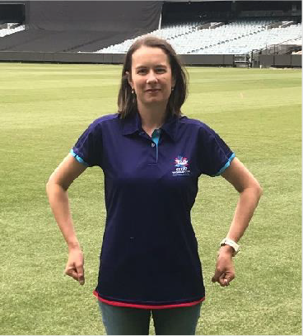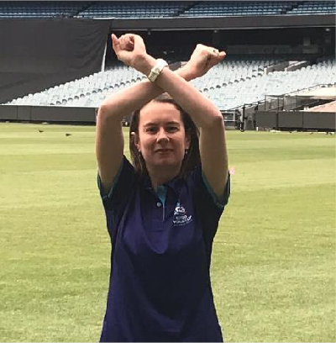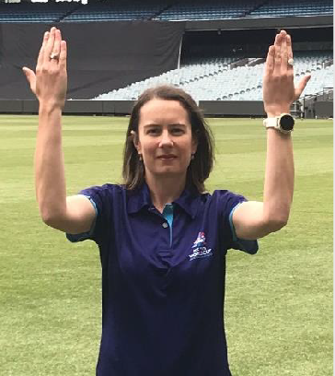**Figure 1.1 Figure 1.2 Figure 1.3**

In an emergency, the Paramedic will determine treatment and lead the extrication team and evacuate the injured player/match official from the field as per the venue specific Emergency Action Plan. However, the Tournament Doctor will remain closely involved in the overall management, communication and reporting of the incident to the ICC.

* 1. **On-Field Injury Assessments and Treatment**

The umpires will allow an initial 4 minutes for medical staff to treat the injured player. Umpires may inform the medical team when there is 90 seconds remaining, after which, the player should be removed from the field of play if further assessment/treatment is required. The on-field umpires will consider each incident when applying the 4-minute guideline.

* 1. **Environmental Conditions**

As per the current playing conditions for all formats of international cricket, Match Officials have the authority to decide if it would be dangerous or unreasonable for play to take place or continue in extreme weather conditions. The TMM will report to Match Officials any concerning temperature/humidity or air quality readings anticipated for the duration of the match day.

The TMM should make themselves aware of the conditions expected during the match and ensure that appropriate advice is given to tournament officials, Match Officials and Team Medical Representatives prior to the commencement of the match.

* 1. **Ambulance and Paramedics**

Please include arrangements with ambulance and paramedics so teams are aware of what facilities will be available on a match day.

Please review the Ambulance and paramedic requirements on page 7of the Minimum Medical Standards document when making arrangements for the Event.

1. **Heat Stress Prevention and Management Strategies**

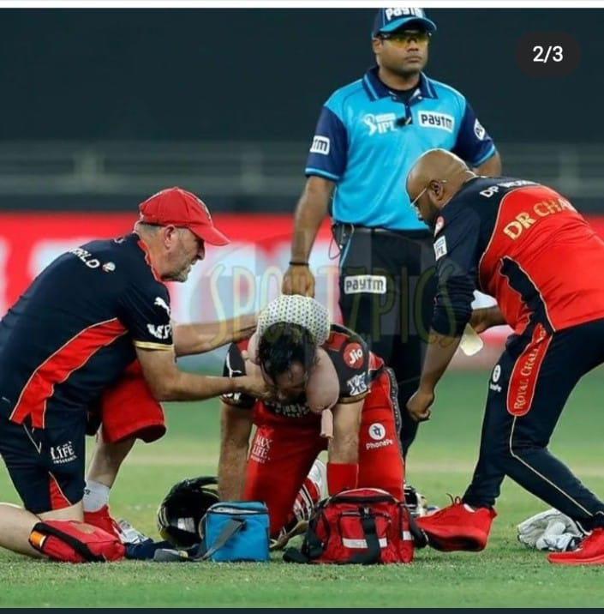

The Heat Stress Management guidelines are designed to negate the effects of heat stress that can result from training and playing cricket in the heat. Cricket is a summer sport so it is expected that some Heat Stress Management Strategies will need to be applied even when the heat related weather conditions are not extreme. These strategies become even more important in extreme heat related conditions.

The following Heat Stress Management Strategies are recommended in part or full at matches (and training sessions).

**i. HYDRATION**

**Pre-Match or Training Sessions**

* Ensure Participants are well hydrated at the start of the match or session.
* Urine Specific Gravity (USG) testing is the most accurate method of monitoring player’s hydration status with an on-waking sample. A value below 1.020 is considered to be acceptable hydration status.

**During Match or Training Session**

* Participants should have access to palatable cool fluids throughout their day / session and breaks in play / training.
* Participants should aim to replace their fluid and sodium losses to maintain adequate hydration.
* Participants' drinks should be individualised to suit their needs.

**Post-Match or Session Rehydration**

* An accurate method to determine fluid loss and rehydration volume required is to calculate Participant’s body weight difference over a session (i.e.: player weigh-in and weigh-out of sessions).
* 150% of the volume difference between pre- and post-session weight should be replaced (re-hydration).
* All Participants should drink the required volume slowly (over hours) to minimise diuresis and choose electrolyte-containing fluids (or consume fluid with a meal) to aid retention.

**ii. COOLING**

A combination of external and internal cooling methods is recommended. Cold ice water immersion techniques should be considered, including -

* Whole body or torso (neck to knee) cooling.
* 30 mins at 22-30°C or 5 mins at 15°C.
* In heat stroke, more rapid and aggressive cooling should be initiated.
* Cold wet towels of crushed ice (approximately 3 kilograms), wrapped in wet towels and taped at the ends and middle.
* Placed on the extremities of the body (neck and face during play and drink breaks).
* Rotation of the towels to different areas of the body is preferable.
* Ideally, this should be used in conjunction with an evaporative fan to maximise cooling effect.
* Where available, change rooms air-conditioning should be set at 22°C-24°C

**iii EVAPORATION**

Participants should avoid wearing compression undergarments during training and matches, particularly in extreme heat related weather.

Industrial type fans in dugout areas to encourage evaporation are a good cooling method. This should be used in conjunction with skin wetting to maximise the cooling effect.

1. **Air Pollution**

Air pollution may be observed in some countries during certain times of the year. Should the air quality in any host country venue pose a cause for concern, the CMO will be responsible for monitoring the AQI readings and providing guidance to the ICC and its participants.

On match days more specifically, both the TMM and the ICC Match Referee will monitor air quality, and the ICC Match Referee will be responsible for applying the ICC guidelines on air quality as required.

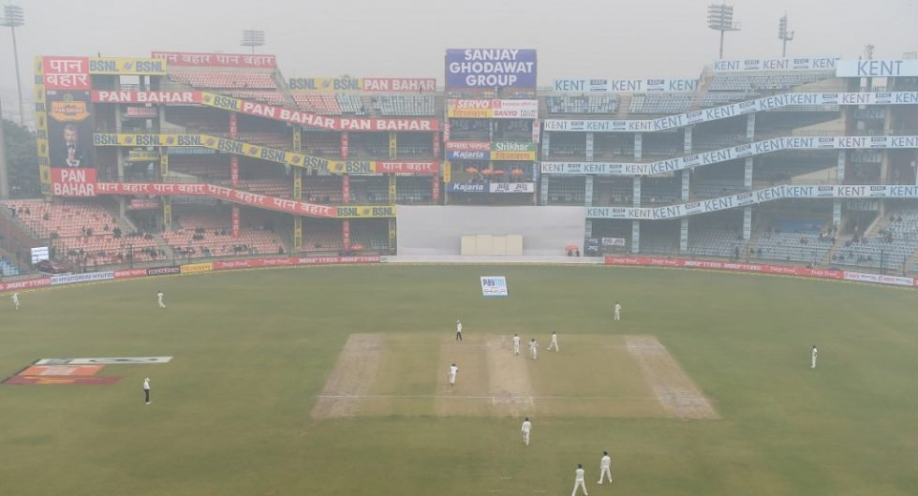

TMRs are encouraged to inform the paramedics at the match day medical briefing if any of their players suffer from respiratory conditions such as asthma. These players will be at higher risk of exacerbation and will need to be monitored closely. TMRs should also encourage their players on match days to inform on-field umpires if they are feeling unwell or having breathing difficulties due to the poor air quality.

1. **Lightning**

In the event of lightning during a match, the ICC Match Referee will (in absence of available distance monitoring devices/technology) apply the 30-30 Rule to determine whether play should be suspended, and the same rule will subsequently determine when it can be safely resumed.

1. **Doping Control**

At the ICC Regional Events, teams will be subject to the ICC Anti-Doping Code and the ICC can carry out drug testing.

Member Boards are requested to ensure their competing players and team management are aware of their anti-doping responsibilities in advance of travelling to the event.

The ICC Anti-Doping team will be happy to deliver education, upon request, to any team in the lead up to the event. However, to ensure players and support staff are prepared well in advance of the tournament, we strongly encourage each Member Board to approach their National Anti-Doping Organisation/National Olympic Committee or the ICC to support them with educating their teams prior to travelling to the tournament.

As part of Anti-Doping Education, all players and support staff are encouraged to download the ‘ICC Integrity App', which is an excellent tool that not only provides easy access to important and useful anti-doping information but also includes the ability to report to the ICC on any integrity concerns.

**ICC Therapeutic Use Exemption (TUE)**

Any player who, for legitimate medical purposes, needs to use medication containing a prohibited substance or using a prohibited method must receive permission to do so by applying for a Therapeutic Use Exemption (TUE) using the ICC TUE Application form available on the ICC website.

TUE applications should be submitted in a secure manner to the ICC (anti-doping@icc- cricket.com). The TUE application form and information on the application/recognition process is available on the Anti-Doping-TUE section of the ICC website.

Please note, it usually takes a minimum of 72 hours and, in some instances, up to two weeks or more to process a TUE application. We therefore request that all TUE applications are complete with the necessary signatures, dates and supporting documentation and, where possible, be submitted at the earliest opportunity.

Any player who has a valid TUE authorized by another Anti-Doping Organisation, other than the ICC, must apply to the ICC for recognition of the TUE prior to the Tournament. The ICC will not automatically recognise TUE’s issued by other Anti-Doping Organisations.

In case of any anti-doping related queries please contact the ICC Anti-Doping Manager.

|  |
| --- |
| **ICC ANTI-DOPING MANAGER** |
| Name: Vanessa Hobkirk |
| Phone: +971 50 6401 402 |

|  |
| --- |
| 1. **HOST COUNTRY INFORMATION** |

**Transport of medication in and out of host country**

Should Team Medical Representatives want to bring their own pharmaceutical products into the host country, care should be taken to adhere to the host country regulations when doing so.

*Include details on host country regulations pertaining to import/export of medication.*

**Vaccinations**

Yellow fever vaccination is required by many countries once persons have travelled to Guyana and Trinidad and Tobago. It is therefore recommended that all persons have evidence of having received this vaccine prior to travel.

*Include details on any specific vaccinations that may be required or recommended.*

**Drinking Water & Food**

It is highly recommended that persons consume bottled water or boiled water in all countries. Whereas many countries have high quality piped drinking water, and most hotels have mechanisms to purify water, it is still recommended that bottled or boiled water be consumed at all times.

**Infectious Disease**

The ICC policy on infectious disease is that participant be always of primary consideration. *[Include information related to any infectious disease that teams should be aware of such as ongoing prevalence in home country, vaccinations, precautionary measures, reporting, symptoms, treatment and other updates from the host country ministry of health etc)*

|  |
| --- |
| **6. CONCUSSION** |

During the Tournament, [ICC Concussion Management Guidelines](https://icc-static-files.s3.amazonaws.com/ICC/document/2019/01/08/718da49b-8c3b-41a4-a879-39156ddeb6bd/ICC-Concussion-Management-Guidelines-Apr-18.pdf) apply to the management of head injuries or suspected concussion with the player’s welfare in mind. The Team Medical Representative (TMR) is required to be familiar with these guidelines before the Event commences.

The match day paramedic should also be experienced in the diagnosis and immediate treatment of concussion.

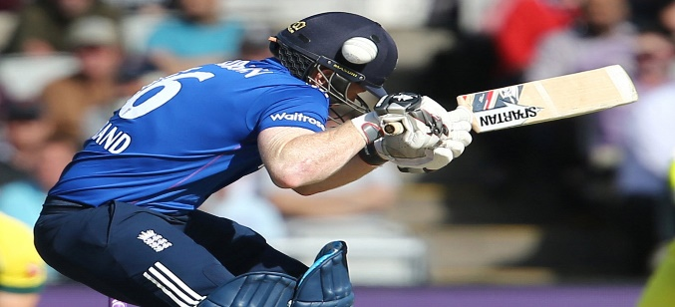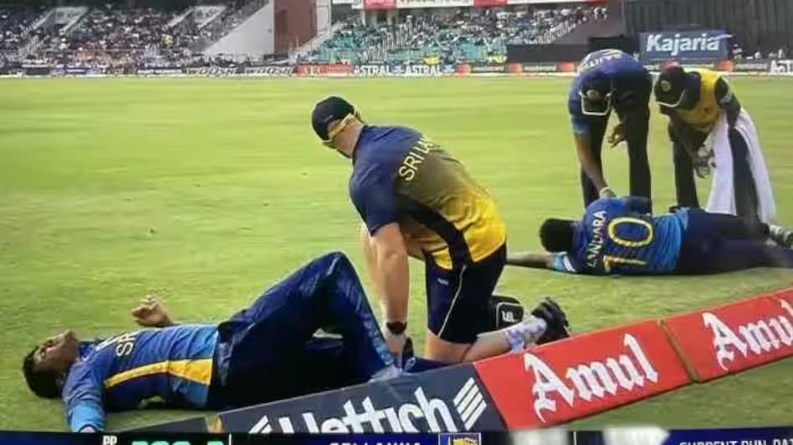

**6.1 CONCUSSION ROLES AND RESPONSIBILITIES:**

**Team Medical Representative**

Each participating team will appoint a Team Medical Representative (TMR) who will be responsible for the wellbeing of the players. Typically, the TMR will be the primary responder in possible concussions and must be aware of the clinical signs and symptoms of concussion ([Pocket Concussion](https://bjsm.bmj.com/content/bjsports/47/5/267.full.pdf) [Recognition Tool](https://bjsm.bmj.com/content/bjsports/47/5/267.full.pdf).). TMRs that are not confident in the assessment of a possible on-field concussion may reach out to the Tournament Doctor/paramedic for assistance. All TMRs must err on the side of safety and, when there is any doubt about a possible concussion, should bring a player off for further or more detailed assessment.

The player can re-enter the field of play if a diagnosis of concussion is not made; or alternatively, if concussion is diagnosed, then a concussion replacement may be introduced after discussion with the Match Referee.

The TMR and Tournament Doctor must also be aware of the possibility of a delayed concussion developing within the first 48 hours after head or neck trauma and monitor all injured players throughout the game and following the conclusion of play.

Once a diagnosis of concussion is confirmed, as per [ICC Concussion Management Guidelines](https://icc-static-files.s3.amazonaws.com/ICC/document/2019/01/08/718da49b-8c3b-41a4-a879-39156ddeb6bd/ICC-Concussion-Management-Guidelines-Apr-18.pdf), the concussed player must be assessed by a qualified medical doctor and has to be cleared by a medical doctor before the player returns to play. On match day, and if concussion has not been diagnosed, the TMR (in consultation with the MDD) will be entrusted to make the final decision on a player’s continuation in the match in accordance with [ICC Concussion Management](https://icc-static-files.s3.amazonaws.com/ICC/document/2019/01/08/718da49b-8c3b-41a4-a879-39156ddeb6bd/ICC-Concussion-Management-Guidelines-Apr-18.pdf) [Guidelines](https://icc-static-files.s3.amazonaws.com/ICC/document/2019/01/08/718da49b-8c3b-41a4-a879-39156ddeb6bd/ICC-Concussion-Management-Guidelines-Apr-18.pdf), having regard to the player’s welfare.

The TMR should also ensure that replacement batting helmets are easily at hand and can be brought on to the field quickly if there is any possibility of damage to a batter’s helmet.

Should any potential concussive injury occur at training or in the nets before a game, the TMR is encouraged to follow protocols in line with [ICC Concussion Management Guidelines](https://icc-static-files.s3.amazonaws.com/ICC/document/2019/01/08/718da49b-8c3b-41a4-a879-39156ddeb6bd/ICC-Concussion-Management-Guidelines-Apr-18.pdf).

***Note – It is expected that all decision relating to head injuries will be in accordance with the*** [***ICC Concussion Management Guidelines***](https://icc-static-files.s3.amazonaws.com/ICC/document/2019/01/08/718da49b-8c3b-41a4-a879-39156ddeb6bd/ICC-Concussion-Management-Guidelines-Apr-18.pdf) ***and in the player’s best interest. To ensure player welfare, the ICC will audit the use of its Concussion Management Guidelines at every ICC event.***

**6.2 CONCUSSION REPLACEMENT**

In 2019, the ICC introduced concussion replacement players into the [ICC Concussion](https://icc-static-files.s3.amazonaws.com/ICC/document/2019/01/08/718da49b-8c3b-41a4-a879-39156ddeb6bd/ICC-Concussion-Management-Guidelines-Apr-18.pdf) [Management Guidelines](https://icc-static-files.s3.amazonaws.com/ICC/document/2019/01/08/718da49b-8c3b-41a4-a879-39156ddeb6bd/ICC-Concussion-Management-Guidelines-Apr-18.pdf). An abbreviated extract from the ICC playing conditions has been included below:

If a player sustains a concussion or suspected concussion as a result of a head or neck injury during the course of the relevant match, a Concussion Replacement may be permitted in the following circumstances:

* + - * the head or neck injury must have been sustained during play and within the playing area;
      * a concussion or suspected concussion must have been formally diagnosed by the TMR or Tournament/Match Day Doctor or paramedic.
      * the TMR or Team Manager shall submit a Concussion Replacement Request to the ICC Match Referee on a standard form, which shall:
        + identify the player who has sustained the concussion or suspected concussion;
        + specify the incident in which the concussion or suspected concussion was sustained, including the time at which it occurred;
        + confirm that, following an examination, the TMR, or in consultation with the Match Day Doctor, believes or suspects that the player has sustained a concussion as a result of the incident specified in above; and
        + identify the requested Concussion Replacement, who shall be a like-for-like replacement for the player who has sustained the concussion or suspected concussion.
      * The decision of the ICC Match Referee in relation to any Concussion Replacement Request shall be final and neither team shall have any right of appeal.

It is expected that the paramedic or tournament doctor will assist TMRs in the assessment of potential concussion on request.

|  |
| --- |
| Medical Services in Host Cities |

This section provides a list of medical services and facilities available to cricket teams and match officials in each host city.

* General Medical Services
* Match Day Medical Services & Facilities
* Medical Services at Training
* Medical Services at Team Hotels

*A separate set of tables should be created for each host city.*

**(Insert name of Host City 1)**

**GENERAL MEDICAL SERVICES**

| *(Insert name of host city 1)* – GENERAL MEDICAL SERVICES | | | |
| --- | --- | --- | --- |
|  | **Name** | **Address** | **Phone** |
| Hospital(s) | *Name of hospital*  *Distance from team hotel (s) e.g. 2km & 5mins*  *Services available at the hospital – for e.g. Private emergency service for most injuries and illnesses requiring some investigation* | *Address of the hospital* | *Telephone number* |
| *Name of hospital*  *Distance from team hotel (s) e.g. 2km & 5mins*  *Services available at the hospital – for e.g. Private emergency service for most injuries and illnesses requiring some investigation* | *Address of the hospital* | *Telephone number* |
| Accident & Emergency |  |  |  |
| Orthopaedics |  |  |  |
| General Surgery |  |  |  |
| General physician |  |  |  |
| Cardiology |  |  |  |
| MSK Radiologist -for case discussion/advice (when necessary) |  |  |  |
| Neurologist (preferably with head injury/concussion experience) |  |  |  |
| Pathology (haematology, biochemistry, microbiology) |  |  |  |
| Pharmacy |  |  |  |
| Dentist |  |  |  |
| Gynaecologist (for women’s event) |  |  |  |
| Physiotherapy |  |  |  |
| Psychiatrist/Counsellor |  |  |  |
| Masseur/masseuse |  |  |  |
| Sports Doctor |  |  |  |
| Podiatrist |  |  |  |

**MATCH DAY MEDICAL SERVICES & FACILITIES**

*In case of multiple match venues in one city, a separate ‘Match Day Medical Services & Facilities’ table should be created for every match venue in the city.*

| *(Insert name of host city 1 – insert name of match venue 1)*match day medical services & facilitiesFFICIALS | | | |
| --- | --- | --- | --- |
| Medical room/tent location at match venue (using a venue map). |  | | |
| Medical room equipped with: | *Refer to Appendix F of the Minimum Medical Standards for Major ICC events and list the equipment in this section.* | | |
| Availability of medical room/tent equipment at the venue on match day | *One (1) hour before the match and thirty (30) minutes after the match has finished* | | |
| Location of ambulance and paramedics. | *Can team expect to see an ambulance stationed at the ground for this venue and if not, explain why and what other measures are in place. If an ambulance is stationed at the ground, ensure it has clear access from the field to the road* | | |
| Availability of ambulance on match day | *At least 1 hour before the start of the match and 30 minutes after the match has finished* | | |
| Ambulance equipped with | 1. *Stretcher - that can safely extricate the patient from the pitch or dressing room to the ambulance and then be fixed in the vehicle for safe transit.* 2. *Spinal Board* 3. *Portable oxygen* 4. *IV fluid access and fluid* 5. *Automatic External Defibrillator* 6. *Supply of essential (lifesaving) medications.* | | |
| Capability of paramedics | *trained paramedic/technician/nurse capable of coping with (i) Cardiac arrest, (ii) Anaphylaxis, (iii) Head/neck injury, (iv) Other serious injury or illness, (v) Bone fracture and (vi) other perceived risk* | | |
| Other medical staff that will be available on match day. |  | | |
| Proposed time & location for Match Day Medical Meeting | *Date & Match* | *Meeting time* | *Location* |
|  |  |  |
|  |  |  |
|  |  |  |
|  |  |  |

**MEDICAL SERVICES AT TRAINING/PRACTICE**

*In case of multiple training venues in one city, a separate ‘Medical Services at Training’ table should be created for every training venue in the city.*

|  |  |  |  |  |  |  |
| --- | --- | --- | --- | --- | --- | --- |
| *(INSERT NAME OF HOST CITY 1 – INSERT NAME OF TRAINING VENUE 1)*medical SERVICES AT TRAINING | | | | | | |
|  | **Name** | | | **Address** | | **Phone** | |
| Closest hospital with accident and emergency centre with emergency ambulance*\** | |  |  | |  | |
| Closest pharmacy | |  |  | |  | |
| Medical cover | | The medical cover is expected to include Team Doctors (if applicable) and Team Physiotherapists. | | | | |
| Medical equipment that will be available at all official practice sessions. Location of medical equipment (i.e. with first responder/paramedic or medical room) | |  | | | | |

*\*If an ambulance is more than 15 minutes away from a practice venue, consideration should be given to having an ambulance and driver stationed at the practice venue.*

**MEDICAL SERVICES AT TEAM HOTELS**

*In case of multiple team hotels in one city, a separate ‘Medical Services at Team Hotels’ table should be created for every team hotel in the city.*

Note – The following medical services will be available to teams and Match Officials **at their own cost.**

| *(INSERT NAME OF HOST CITY 1 – INSERT NAME OF TEAM HOTEL 1)*MEDICAL SERVICES AT TEAM HOTELS | | |
| --- | --- | --- |
|  | Name & address | Phone |
| Ambulance for serious emergency situations |  |  |
| Preferred private hospital with accident and emergency centre |  |  |
| Preferred pharmacy (*open late*) |  |  |
| Hotel out-of-hours/on-call service doctor (not to be relied upon for speedy response). This is only where this service is available and if utilised it will be at the team’s cost. |  |  |
| Preferred dental facility |  |  |

**HOST CITY 2.**

**GENERAL MEDICAL SERVICES**

*(Insert ‘General Medical Services’ table for Host City 2)*

**MATCH DAY MEDICAL SERVICES & FACILITIES**

*(Insert ‘Match Day Medical Services & Facilities’ table(s) for Host City 2)*

**MEDICAL SERVICES AT TRAINING**

*(Insert ‘Medical Services at Training’ table(s) for Host City 2)*

**MEDICAL SERVICES AT TEAM HOTELS**

*(Insert ‘Medical Services at Team Hotels’ table(s) for Host City 2)*

**HOST CITY 3…..**

**GENERAL MEDICAL SERVICES**

*(Insert ‘General Medical Services’ table for Host City 3)*

**MATCH DAY MEDICAL SERVICES & FACILITIES**

*(Insert ‘Match Day Medical Services & Facilities’ table(s) for Host City 3)*

**MEDICAL SERVICES AT TRAINING**

*(Insert ‘Medical Services at Training’ table(s) for Host City 3)*

**MEDICAL SERVICES AT TEAM HOTELS**

*(Insert ‘Medical Services at Team Hotels’ table(s) for Host City 3)*